PHASE 6
PROJECT TESTING
INTRODUCTION:
TEAM ID : SWTID-2026-5475
TEAM LEADER: DHARANI S
MAIL ID : banudharanid@gmail.com
Team members:
NAME: | MAIL ID:
Chanda A | ajaykumarsinge240@gmail.com
Komal O | Komal.27.250@gmail.com
Srinithi B | Praveena100314@gmail.com

the project documentation states that the REST APIs can be tested using Postman or Thunder Client. Thte supplied screenshots are included below as testing evidence.

Register API
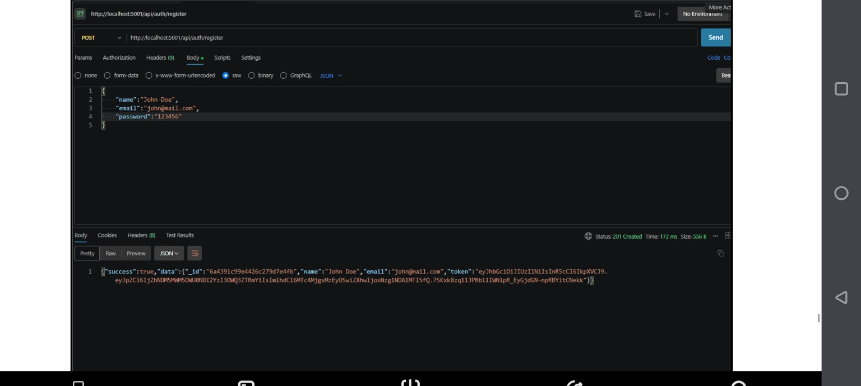
Register API — HTTP 201 Created

Weather API
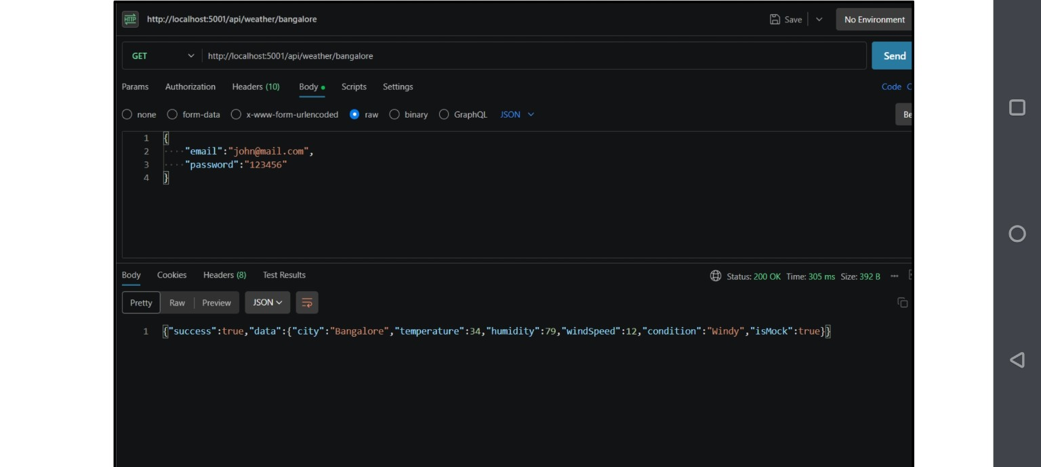
Weather API — HTTP 200 OK

Recommendation API
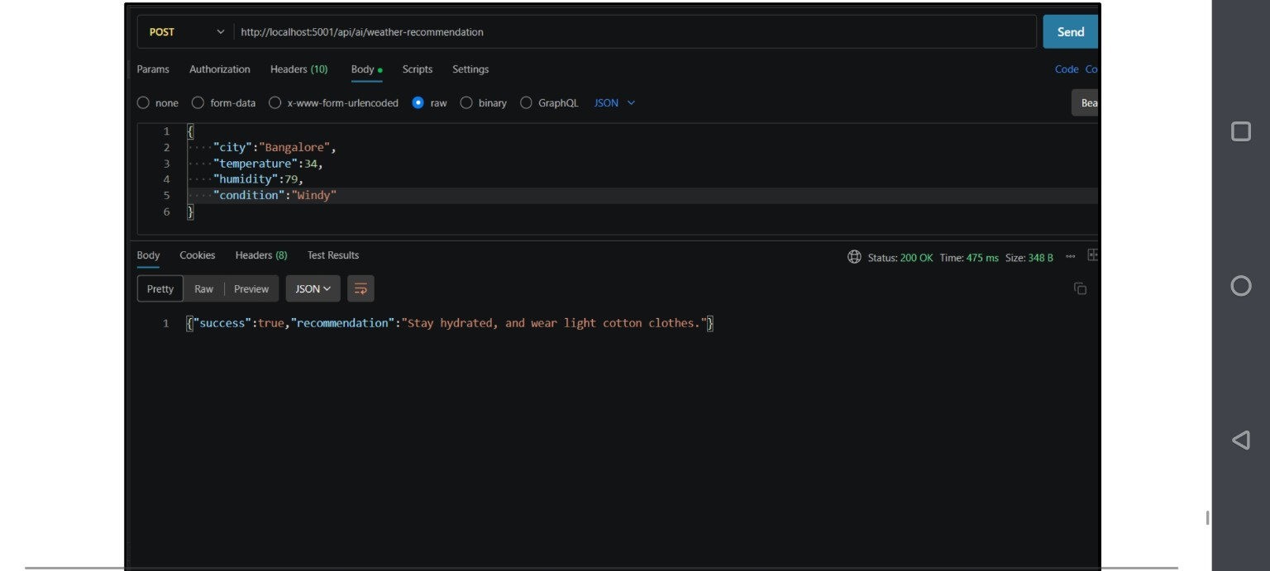
Weather Recommendation API — HTTP 200 OK
Testing result: the supplied screenshots show successful API responses for registration, weather retrieval and weather recommendation. The original documentation also lists Login API testing.

